Team Name: Team NOSS

Team Number: 4-6pm Group 105

Team Leader: Sam Morgan

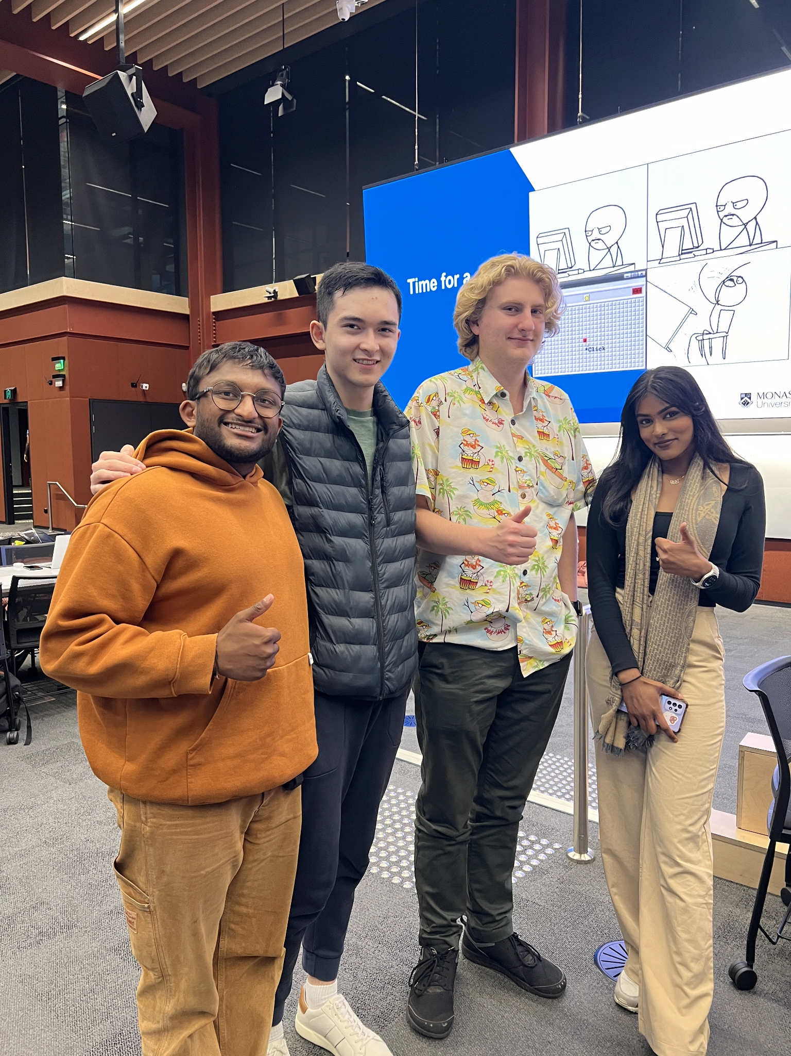

Samuel Morgan

Email: [smor0055@monash.edu](mailto:smor0055@monash.edu)

Technical and Professional Strengths:

* Experienced programmer, with a depth of experience working in OOP.
* Completed various placements working amongst different professional teams, as such has experience in cooperation, communication and planning.
* Personal experience working in Game Development, and the multidisciplinary concepts that require.

Fun fact: I own a pet turtle named Squirt.

[Sona Hariharan](mailto:shar0108@student.monash.edu)

Email: [shar0108@student.monash.edu](mailto:shar0108@student.monash.edu)

Technical and Professional Strengths:

* Programming experience in python and java
* Team collaboration experience from several projects in university
* Experience in code testing (unittest and CI/CD)
* Experience developing an application while following Agile workflow as a team

Fun fact: I have a sister ~16 years younger than me

Nick Ballard  
Email: [nbal0023@student.monash.edu](mailto:nbal0023@student.monash.edu)

Technical and Professional Strengths:

* Proficient in python and java
* Experience developing desktop, web and mobile applications
* Previously used the Agile development methodology to manage projects

Fun Fact: I am a dual citizen (AUS/USA)

Omila Herath

Email: [oher0004@student.monash.edu](mailto:oher0004@student.monash.edu)

Technical and Professional Strengths:

* Proficient in python, java and some pyTorch
* Extensive experience working in Uni based team tasks and Projects
* Personal Experience in creating Reinforcement Learning based projects and interested in AI

Fun Fact: I’m training for a Half Marathon